**LAB 5**

**5.1 Write a program that prints “yes” if the given integer is divisible by 2 or 3 and “no” otherwise.**

**SOURCE CODE**

#include <iostream>

using namespace std;

int main ()

{

int a;

cout<<"Enter the number to be checked"<<endl;

cin>>a;

if (a%2!=1||a%3!=1)

cout<<"YES"<<endl;

else

cout<<"NO"<<endl;

return 0;

}

**OUTPUT**

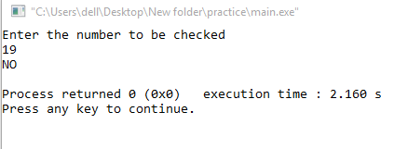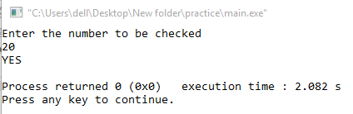

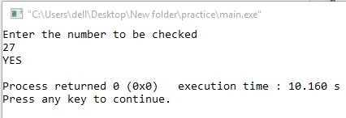

**5.2 Write a Program that prints “Take a day off!" if it takes the number of customer greater than 50 and their total sum would be greater or equivalent to 5000.**

**SOURCE CODE**

#include <iostream>

using namespace std;

int main ()

{

int a,b=0;

cout<<"Enter the number of customers"<<endl;

cin>>a;

for(int i=1; i<=a;i++)

{

b+=i;

}

cout<<"total no. of customers are "<<a<<endl;

cout<<"Sum of all customers is "<<b<<endl;

if (a>50&&b>5000)

cout<<"take a day off!"<<endl;

return 0;

}

**OUTPUT**

